EXPERIMENT – 12
Iris Flower Classification using K-Nearest Neighbours (KNN)
AIM
To implement the K-Nearest Neighbours (KNN) algorithm in Python for classification of Iris flowers into different species.
APPARATUS REQUIRED
- Google Colab
- Python 3.x
- NumPy
ALGORITHM
- Start the program.
- Import the required Python libraries.
- Load the Iris flower dataset.
- Separate the input features and target classes.
- Split the dataset into training and testing data.
- Create a KNN classifier with a suitable value of K.
- Train the KNN classifier using the training data.
- Predict the class of the test data.
- Calculate the classification accuracy.
- Display the classification results.
- Stop the program.
PROGRAM
# Experiment 12: Iris Flower Classification using KNN
# Import required libraries
import numpy as np
import pandas as pd
import matplotlib.pyplot as plt

from sklearn.datasets import load_iris
from sklearn.model_selection import train_test_split
from sklearn.neighbors import KNeighborsClassifier
from sklearn.metrics import accuracy_score, confusion_matrix
# Load Iris dataset
iris = load_iris()
X = iris.data
y = iris.target
# Split the dataset into training and testing data
X_train, X_test, y_train, y_test = train_test_split(
X, y, test_size=0.2, random_state=42
)
# Create KNN classifier
knn = KNeighborsClassifier(n_neighbors=5)
# Train the model
knn.fit(X_train, y_train)
# Predict test data
y_pred = knn.predict(X_test)
# Calculate accuracy
accuracy = accuracy_score(y_test, y_pred)
print("Accuracy:", accuracy)
# Display confusion matrix
cm = confusion_matrix(y_test, y_pred)

print("\nConfusion Matrix:")
print(cm)
# Predict a new flower sample
new_sample = [[5.1, 3.5, 1.4, 0.2]]
prediction = knn.predict(new_sample)
print("\nPredicted Flower:", iris.target_names[prediction][0])
OUTPUT
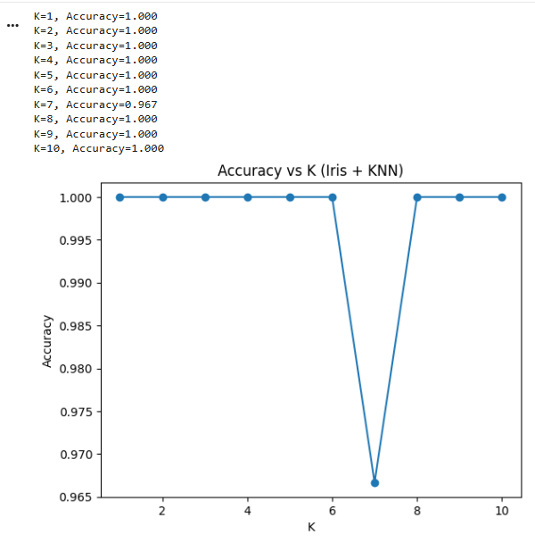
RESULT
Thus, the Iris Flower Classification using KNN algorithm was successfully implemented using Python in Google Colab, and the flower classification results were obtained.

